**Defenders Optimization Handout**

**(Level 1/Wave 1)**

Adam Mao and Riu Sakaguchi

**Main Effects**

**Q1. Why is Location Combination 12 better than 13?**

**Q2. Why is Location Combination 13 better than 14?**

**Q3. Why is Location Combination 24 better 34? (For Percent Destroyed)**

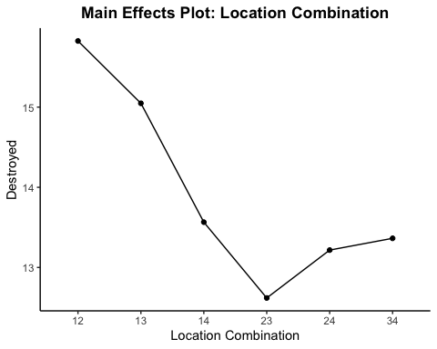

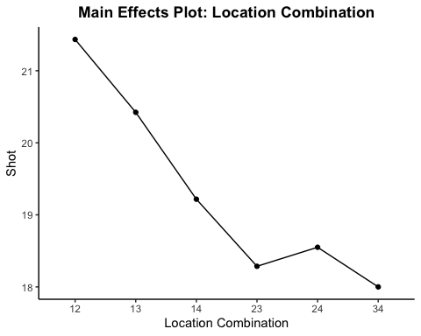

**Interactions – Both Viruses**

**Q. Why is Location Combination 12 better than 13 or 14?**

**Interactions – Red Virus**

**Q. Why is Location Combination 12 better than 13 or 14?**

**Interactions – Blue Virus**

**Q. Why is Location Combination 12 better than 13 or 14?**

**Game Screenshots**

**Interactions – Upgrades Allowed**

**Q1. Is it worthwhile to purchase an upgrade?**

**Q2. Should you get one upgrade or two?**

**Q3. Should you get a fast upgrade, a far upgrade, or both?**

**Q4. If you get an upgrade, where is the proper placement?**

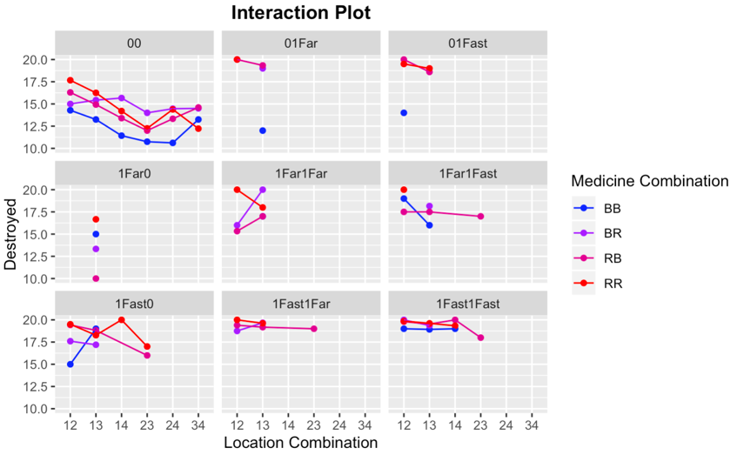

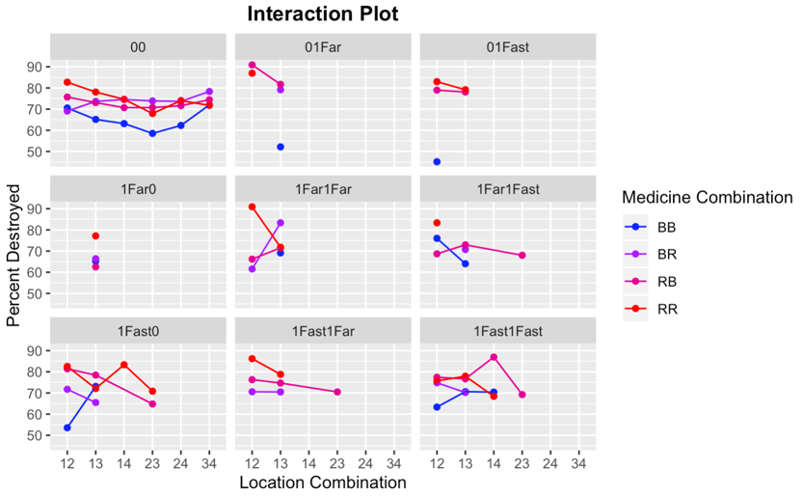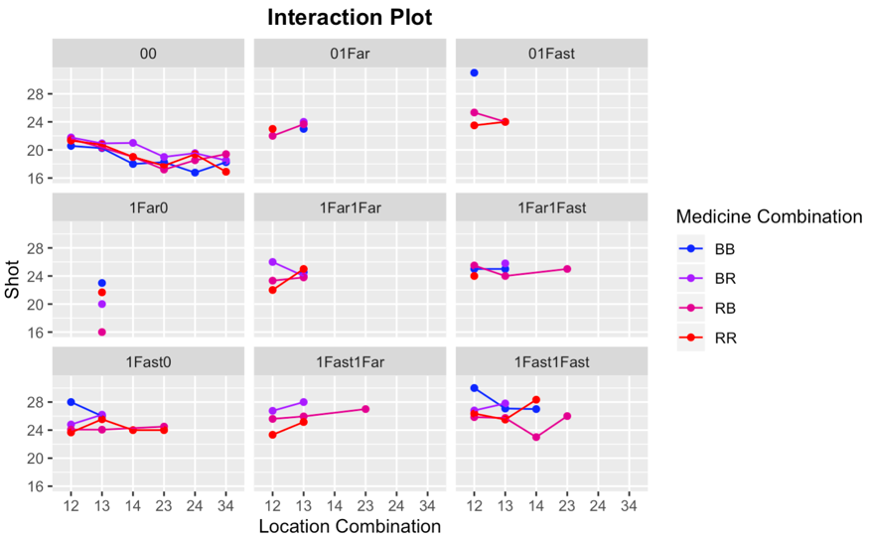

**Tables**

**No Upgrades**

**Upgrades Allowed**